# MICROPROCESOR AND INTERFACING EXPERIMENT 7

M.S.SANJAY

15BCE0517

7) ALP for searching an element in an array.

Code:

data segment

string1 db 11h, 22h, 33h, 44h, 55h

msg1 db "Found$"

msg2 db "Not Found$"

se db 33h

data ends

print macro msg

mov ah, 09h

lea dx, msg

int 21h

endm

code segment

assume cs: code, ds:data

start:

mov ax, @data

mov ds, ax

mov al, se

lea si, string1

mov cx, 04h

up:

mov bl, [si]

cmp al, bl

jz fo

inc si

dec cx

jnz up

print msg2

jmp end1

fo:

print msg1

end1:

INT 21

code ends

end start

Output:

Element Found:

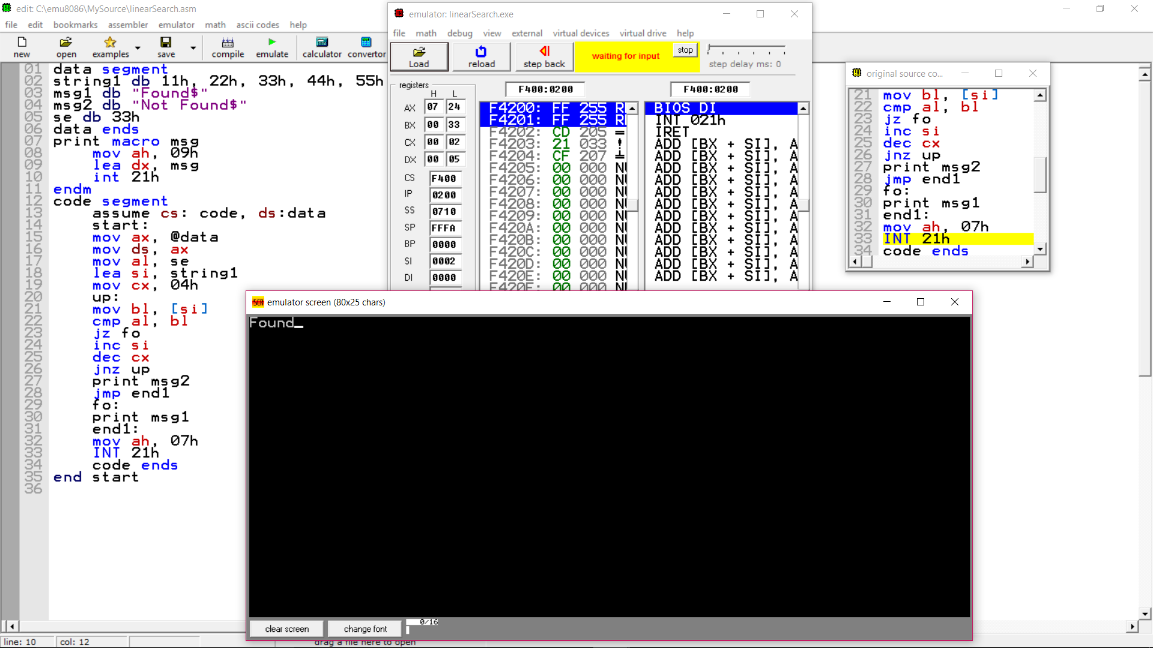

Element Not Found:

